Multirobot Adaptive Navigation of 2-D Vector Fields

Table of Contents
#0. Abstract 2
#1. Introduction 2
#3. Formation Control Using Cluster Space 3
#4. Vector Fields 4
#3.1 Fundamental Bases for Constructing Vector Fields 4
#4.2 Vector Fields - Regions of Interest 6
#5. Control Primitives 10
5.1 Vector to Scalar Technique 10
5.2 Direction Follower Technique 10
5.3 Vector Sum Technique 11
5.4 Intersecting Vectors Technique 11
5.5 Non-linear Techniques 11
# 6. Simulation Results and Discussion 11
#7. Conclusions and Future Work 16
Impact and Applications 16
#7. References 17

#0. Abstract

Rewritten 0130:
This paper presents an innovative method for constructing vector fields through the superposition of basis vector fields, and highlights key regions within these fields, such as local extrema, stagnation points, and separatrix trajectories. We recap a centralized method of formation control for multirobot systems known as cluster control, which we implement as the base layer of our control strategy. Our work develops several adaptive control primitives, based purely on reactive control, enabling price navigation towards vector field features of interest. These primitives have been validated through extensive simulations, demonstrating their effectiveness for us in multirobot adaptive navigation. The performance of each of these primitives are discussed, including insights into potential applications in real world scenarios that are modeled as complex vector field environments. This research contributes significantly to the domain of adaptive navigation of multirobot systems in vector fields, enabling implementation in complex and dynamic environments.

Original 0125:
This document describes how vector fields can be constructed from simpler basis vector fields using superposition and identifies regions of interest within these environments including local extrema, stagnation points, and separatrix trajectories. It recaps cluster control formulation, a centralized method of formation control for multirobot systems. A few control primitives are developed, which rely purely reactive control for navigation to targets which are the features of interest in vector fields. These control primitives are then demonstrated in simulation, multirobot control for formation and navigation was demonstrated. The performance of each control primitive is then discussed, followed by a brief explanation on how they can be implemented on a physical test bed.

#1. Introduction

Multirobot systems are coordinated groups of robots that often have capabilities beyond that of individual robots [1][2]. In a multirobot system, each robot offers speed, precision, repeatability, safety, and resilience to extreme environments [3]. When grouped into a multirobot system, the system has additional advantages such as redundancy, expanded coverage, and collaborative task execution, which is vital for missions ranging from search and rescue to environmental monitoring [4-5].
When the environment is known or mapped, path planning can be effectively executed using predefined navigation methods. In instances where environmental knowledge is limited, Adaptive Navigation methods update a vehicle’s desired trajectory in real time using environmental readings as inputs [28]. These methods retain the benefits of being able to withstand harsh conditions, but further allow reactive control, enabling robots to navigate in environments dynamic or communication-restricted environment [6]. Multirobot Adaptive navigation in scalar field environments is well studied in both simulation and practice. This includes formation control using centralized and decentralized architectures, and developing control strategies for extremum seeking, contour following, and other regions of interest [7-11]. Use cases for this include tracking contamination areas, oil spills and source points [12-15], and plume front tracking [16].
Extending these methods to vector field environments, most of the work done is using artificial vector fields for formation control [17-19]. There are only a few using distributed vector readings from a multirobot system in a vector field [20-23]. It has been shown in simulation that control primitives for multirobot systems exist, including methods for navigating to the fastest flowing point in a stream, navigating to the center of a vortex, sink or source, as well to the center of a sinking vortex [24]. Indoor test beds have also been developed to demonstrate a few of these primitives [22]. This extension to vector fields provides multirobot systems with new methods to navigate extreme environments in fluid flow fields such as rivers, oceans, and aerial spaces [21-24]. Moreover, this extension allows for adaptive navigation methods to be used in extraterrestrial settings autonomous navigation through non-uniform gravitational fields, magnetic fields, and thermal gradients, and other vector fields, such as during asteroid mining [25] [26].
In this paper, we extend further into vector field navigation using multirobot systems with centralized control. Section 2 covers the high-level architecture of the robot formation. In Section 3, the paper discusses different basis for creating vector fields using superposition and introduces a list of features of interest. Section 4 defines control primitives used to navigate to each feature of interest in a purely reactive manner. Section 5 discusses the performance of these control primitives in simulated environments. Section 6 closes this work with future research efforts in the field. This work contributes to the baseline knowledge of adaptive navigation of multirobot systems in vector fields.

# 2. Methodolody

#3. Formation Control Using Cluster Space

Cluster Space control is a technique developed by Dr. Chris Kitts of Santa Clara University. In this technique, all robot positions are described geometrically relative to a cluster frame. A generalized cluster in a 2-dimensional plane can be seen in figure 1. For this research, p=q= 0.854, and beta = 4pi/35 were chosen as our cluster variables. The robot orientation pose variables are not used, as the robots are assumed to be omnidirectional for this discussion.

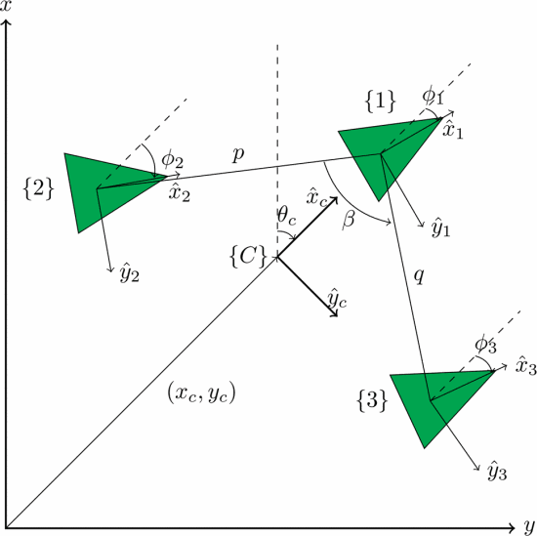
Figure 1. A 3-robot cluster with cluster formation variables shown.
NB. The current cluster space controller is limited to this configuration and maintains this formation exactly. Work to allow a fully designed cluster controller (or any multi-robot controller) is currently being done.

#4. Vector Fields

#3.1 Fundamental Bases for Constructing Vector Fields

Modeling steady-state potential fields in naturally occurring physical domains can be done using equations that involve the Laplace Operator. This motivates the idea that solutions to the Laplace equation can act as a basis function for building more complex vector fields using superposition. These solutions form the basis of the following 5 vector fields, and compound vector fields are constructed using superposition of these basis. This technique was used to model environments for our simulations.
- Uniform Flows (Fig 4)
- Sources and Sinks (Fig 5)
- Fixed Vortex and Free Vortex (Fig 6)
- Dipoles (Fig 7)
- Corner Flow (Fig 8)

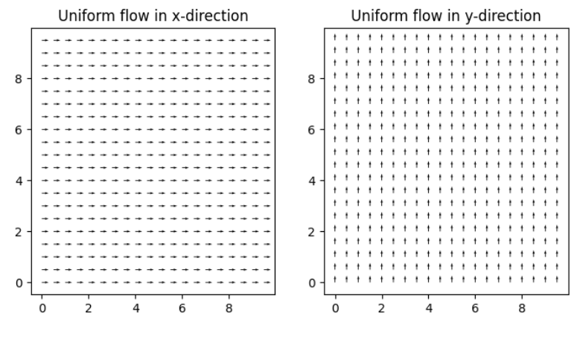
Figure 4 Uniform Flow Fields

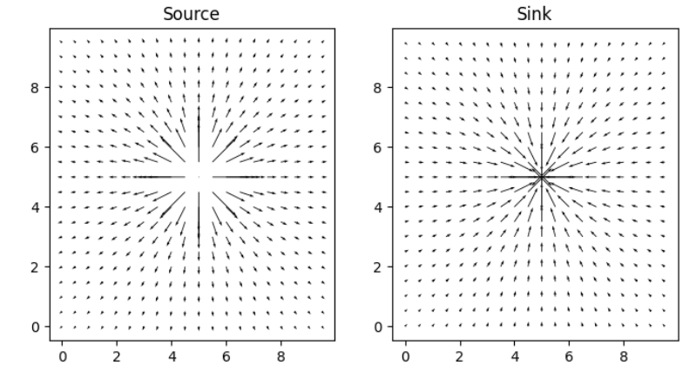
Figure 5. A source and a sink

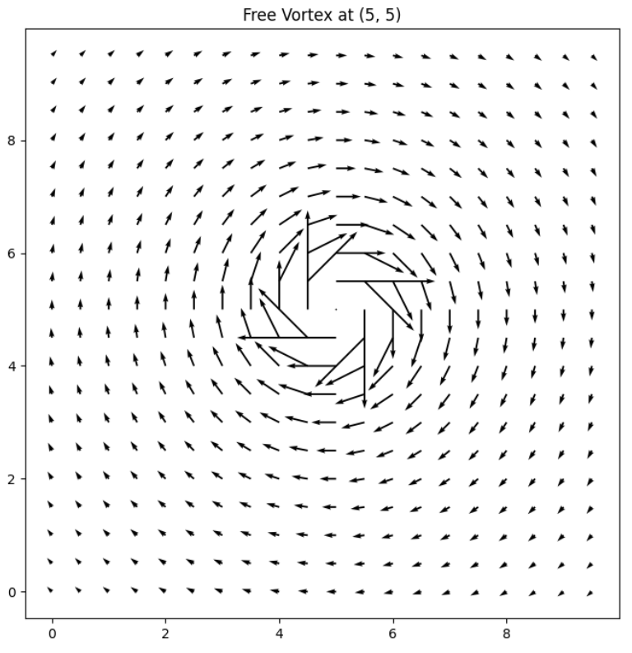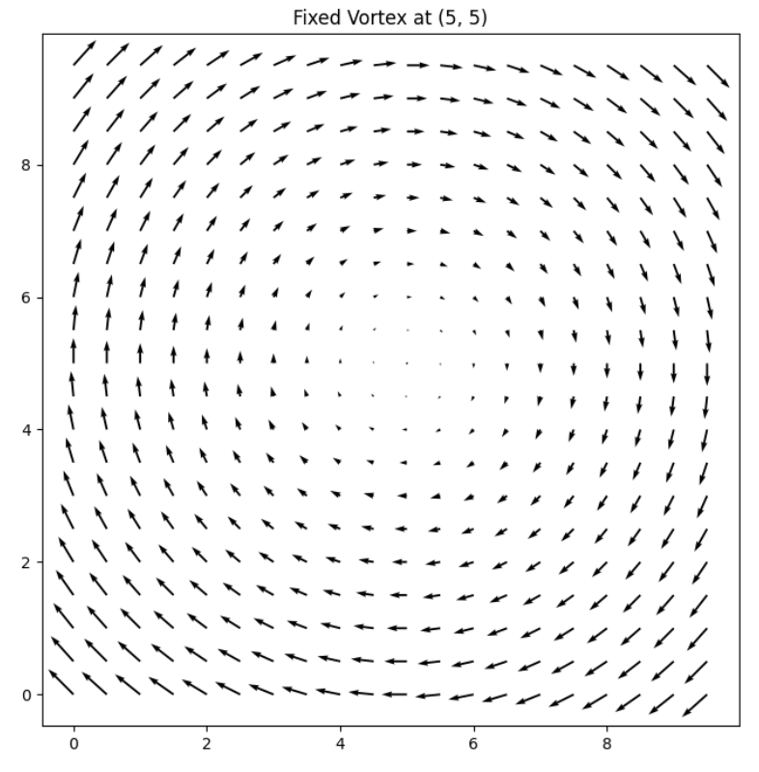
Figure 6. Vector Fields for Free Vortex (Left) and Fixed Vortex (Right)

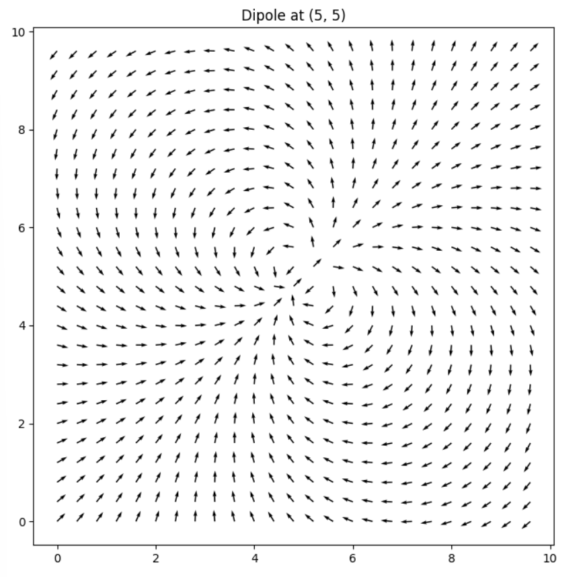
Figure 7. Vector Field of a Dipole – Magnitudes are normalized.

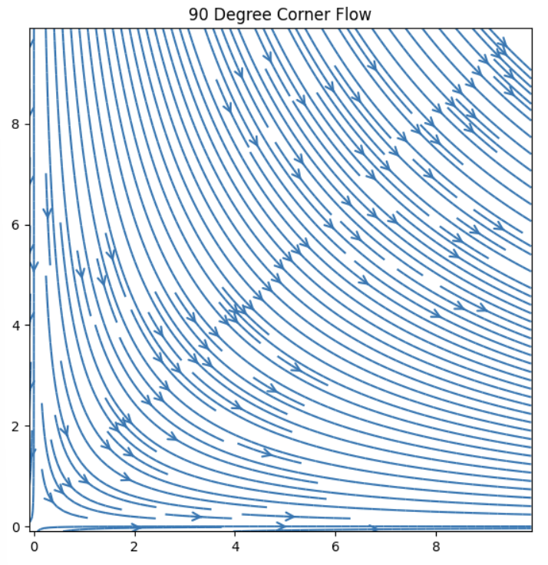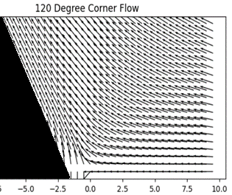
Figure 8. Flow around a 90-degree corner and a 120-degree corner

#4.2 Vector Fields - Regions of Interest

Table 1 describes all interesting features that can be identified in figures 4-8. Some of these features are visualized in figures 9 and 10.
Table 1: Regions of Interest Identified in Basis Vector Fields
Type of Vector Field | Regions of Interest Identified
Uniform Flow | -
Sink/ Source | Centre, equidistance orbit from Centre
Free/Fixed Vortex | Centre, equidistance orbit from Centre
Dipole | Centre, equidistance orbit from Centre
Corner Flow | Boundary Layer

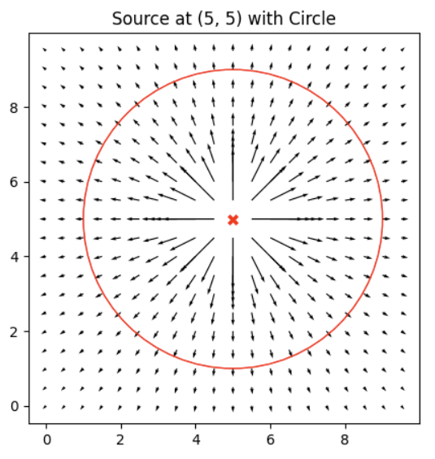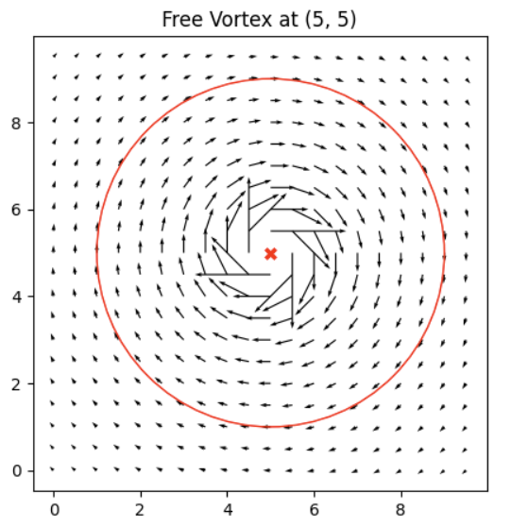
Figure 9. Flow around a 90-degree corner and a 120-degree corner

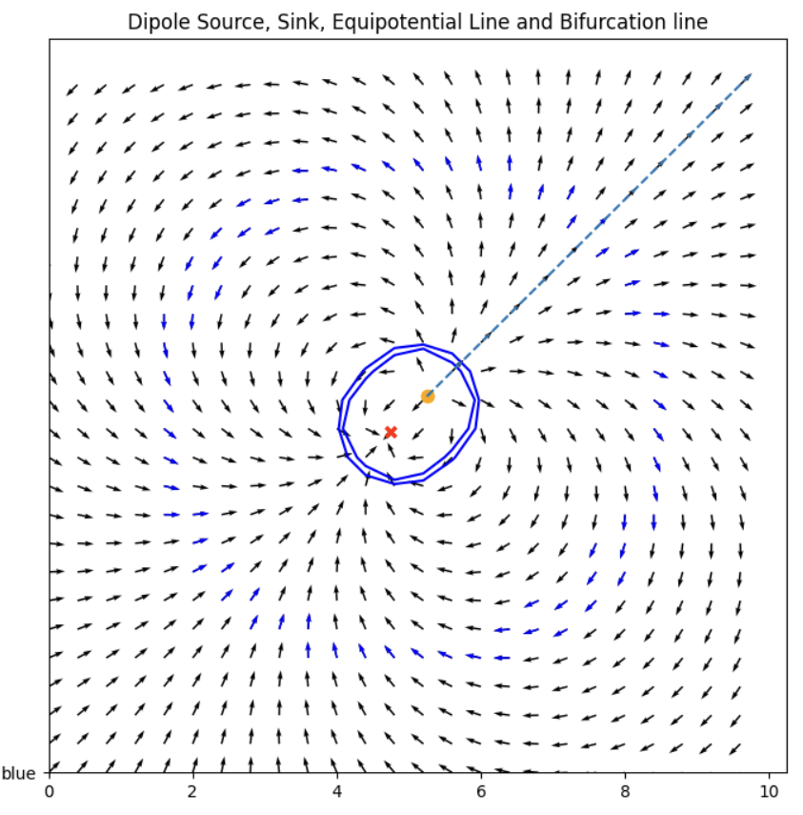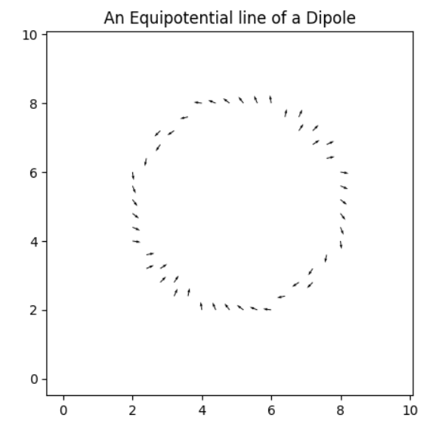
Figure 10: Sink, Source, The Separatrix, Equipotential Lines of Dipole
When these vector fields are superimposed on each other, additional Regions of interest can be observed and identified. It includes additional features such as stagnation points (saddle points), separatrix lines and fastest flow streams. Table 2 identifies all regions of interest that I could identify.

Table 2: Regions of Interest Identified in Basis Vector Fields
Compound Vector Fields | Regions of Interest Identified | Examples of these regions in Nature
Rankine Vortex* | centre, equidistance lines, Fastest flow (ridge)
Vortex + Sink | centre, equidistance lines
Spring + Stream | centre, magnitude contour lines, stagnation zone, separatrix, fastest flow
Opposing Vortices | magnitude contour lines, stagnation zone, separatrix, fastest flow
Co-Rotating Vortices | Centres, magnitude contour lines
Vortex in Stream | centre, stagnation zone, separatrix
Non-uniform streams | Fastest flow, slowest flow, inflection point
Opposing Streams | stagnation zone, separatrix, fastest flow

* Rankine Vortex is a fixed vortex inside a free vortex. Hurricanes often have this shape.
By combining many flows and additional fluid dynamics, features such as monkey saddle points and stable stagnation zones can be created. These features remain beyond the scope of this research. Furthermore, there may be scalar field regions of interest such as tunnels and overhangs that do not have vector field equivalents.
Figures 11 through 16 visualize these compound fields, as well as identify the regions of interest listed in Table 2. These images will be replaced shortly with clearer ones.

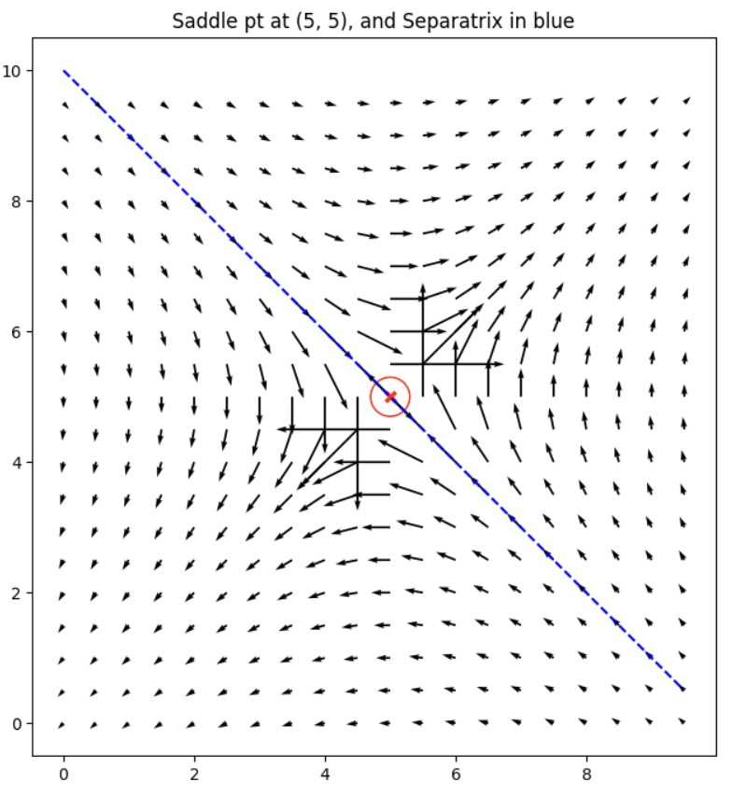
Figure 11: Opposing Streams showing Saddle Points and Separatrix

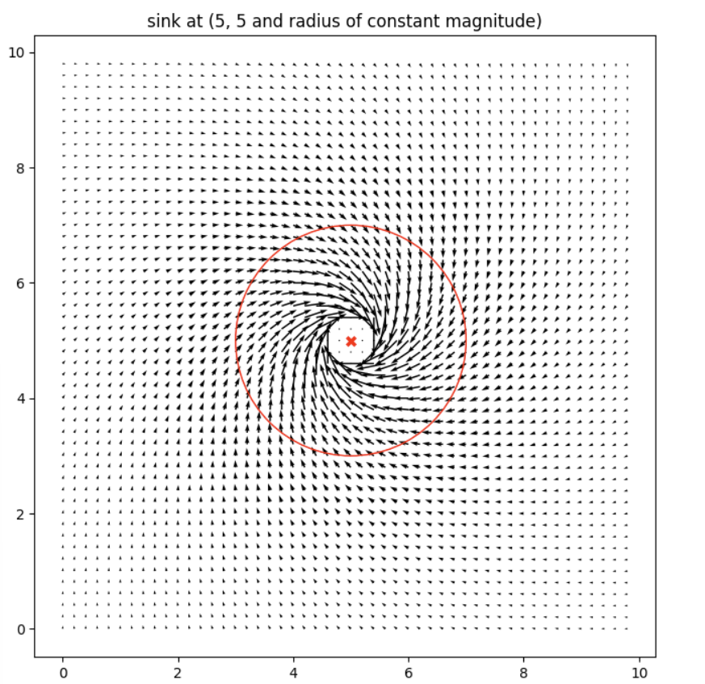
Figure 12: Sinking Vortex, showing the centre, and an orbit of constant radius around it

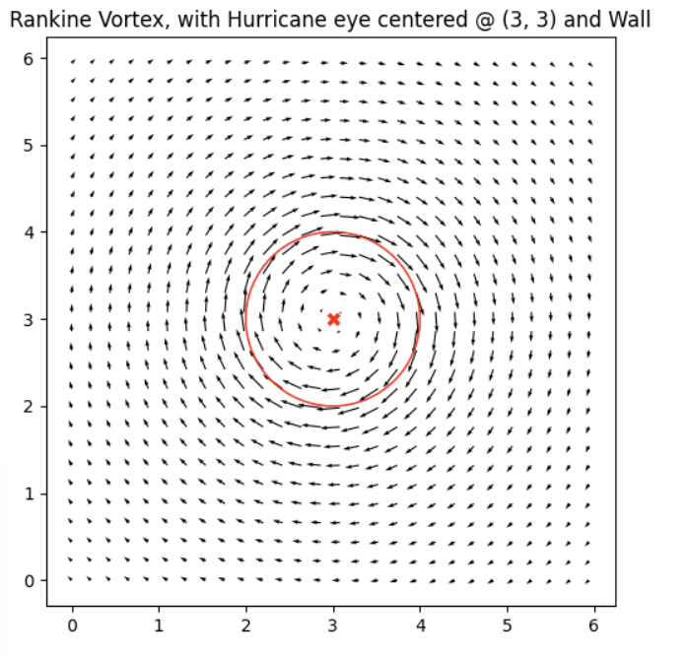
Figure 13: Ranking Vortex, showing the centre, as well as the fastest flow ridge.

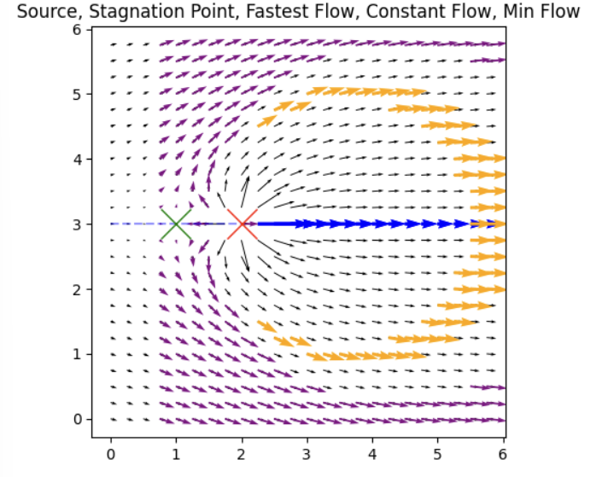
Figure 14: Spring in Stream - Source, Stagnation Point, Fastest Flow, Constant Flow

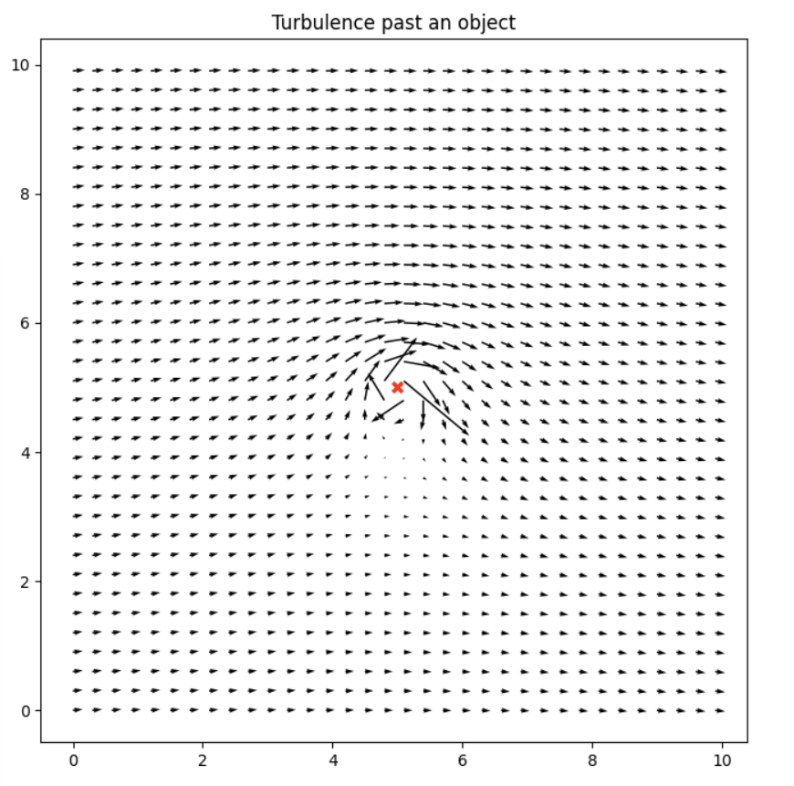
Figure 15: Vortex in a steam without labelled features.

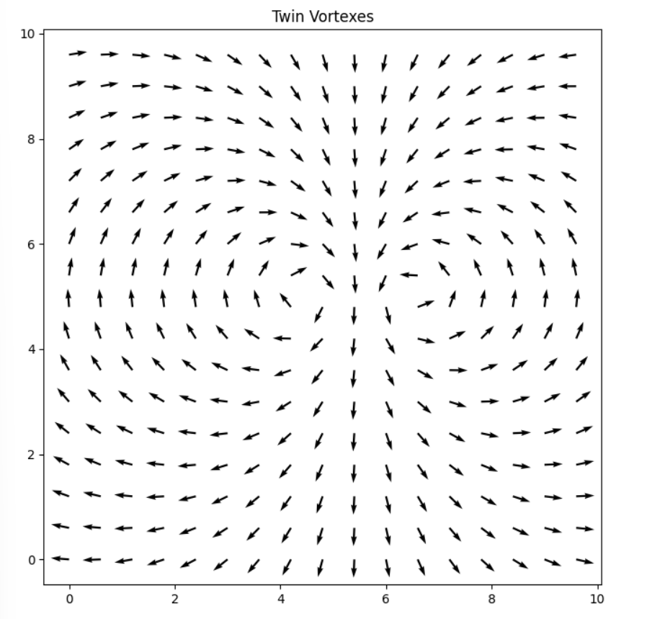
Figure 16: Vortex in a steam without labelled features.

#5. Control Primitives
Previous researchers established two classes of primitives known as the vector to scalar technique, and the direction follower technique. These will be described briefly, and 3 more techniques will be introduced in this section.
5.1 Vector to Scalar Technique
In the technique, only the magnitude information from the vector readings is used. Differences in sensor readings from the individual robots can be used to calculate the gradient and provide a direction of steepest change. The equations used to do this are seen in figure 17. NB: The gradient becomes ill defined if the 3 robots formed a straight line.
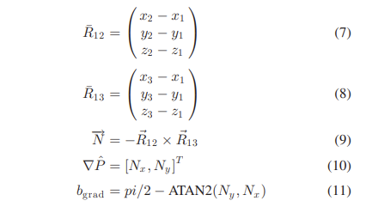
Figure 17. Computing the gradient using the normal vector to the plane [fig from7]

5.2 Direction Follower Technique
This technique uses only the direction information from the vector readings. Each vector reading is normalized, effectively removing magnitude information, then summed. The direction of the resultant vector is then used to direct the multirobot system.

5.3 Vector Sum Technique
This proposed technique is a modification to the direction follower technique, in that the vectors are not normalized before summing. This may lead to improvements when larger vectors are more important.

5.4 Intersecting Vectors Technique
For each pair of robots, the intersection point of their vectors is calculated and then averaged. This calculated point provides an estimated position for certain features of interest such as sinks. This guides the cluster towards, away, or around that feature based on distributed knowledge.

5.5 Non-linear Techniques
In this technique, vectors are ranked by some criteria, then the direction of travel is determined by selecting either the median, max, or min value. For example, the mean vector could be computed, and the vector with the largest L2 norm to the resultant mean vector can be chosen. This technique is key in accomplishing separatrix line riding.

# 6. Simulation Results and Discussion
An initial investigation into vector field navigation demonstrated success in navigating towards a few key regions. A summary of their successes, as well as the techniques used are listed in table 3.
Table 3: Regions of interest that are demonstrated in the Initial Exploration Paper
Basis | Region of Interest | Magnitude Only | Direction Only
Sink/Source | Source point (extremum)  Constant Radius | (fig 9)  - | (fig 8)  -
Fixed Vortex | Centre Point  Constant Radius | -  (fig 10) | -  -
Sinking Vortex | Centre Point  Constant Radius | (fig 12)  - | (fig 11)  -
Nonuniform  Stream | Fastest/slowest Flow | - | (fig 13,14)

They also demonstrated that these primitives can then be used sequentially to perform missions, such as the Fastest Flow Finder Technique. In this mission, they use direction readings only to reconfigure the cluster shape then use magnitude information only to navigate to the fastest flow in a stream. It is called the fastest flow finder because it seeks the crest in the vector field velocity profile, where flowing water would be flowing at the highest flow rate. They mention one potential application could be to find the best locations for fish farms and waterway garbage collection.

Table 4 is an expanded version of this table, showing all the regions identified previously in Tables 1 and 2. A legend for the table is below. Roughly half of the points have at least 1 control primitive. Technique 5 is a new discovery, and will be tested on other separatrix/ridges soon.
Expanded Table 4: A Full list of all features I was able to find and using which technique.
Basis | Region of Interest | Magnitude Only (1) | Direction Only (2) | Other Technique
Sink/Source | Source point (extremum)  Constant Radius | 1  1 | 2  2 | 4  4
Fixed Vortex | Centre Point  Constant Radius | 1  1 | 2  2 | -  -
Free Vortex | Centre Point  Constant Radius | 1  1 | 2  2 | -  -
Dipole | Centre  Equipotential Lines  Separatrix / ridge  Slipstream or trench | 1  1  -  - | 2  X  X  - | -  -  5  -
Sinking Vortex | Centre Point  Constant Radius | 1  1 | 2  X | -  -
Spring in Stream | Find Source Point  Orbit Source Point  Stagnation Point / saddle  Orbit stagnation point  Constant Magnitude  Separatrix / ridge  Fastest Flow if downstream | 1  -  1  -  -  -  - | X  X  X  X  X  X  - | -  -  -  -  -  -  -
Nonuniform  Stream | Realignment  Fastest/slowest Flow  Inflection Point  Uniform flow  Stagnation Point | -  -  -  -  - | -  -  -  -  - | -  -  -  -  -
Vortex in Stream | Find Source Point  Orbit Source Point  Stagnation Point / saddle  Orbit stagnation point  Constant Magnitude  Separatrix / ridge  Slipstream or trench | 1  -  1  -  -  -  - | X  X  X  X  X  -  - | -  -  -  -  -  -  -
Opposing Vortices | Find Source Point  Orbit Source Point  Stagnation Point / saddle  Orbit stagnation point  Separatrix or Ridge  Slipstream or trench  Constant Magnitude | 1  -  -  -  -  -  1 | -  -  -  -  -  -  - | -  -  -  -
Corotating Vortices | Find Source Point  Orbit Source Point  Separatrix of Ridge  Slipstream or trench  Constant Magnitude | 1  -  -  -  1 | -  -  -  -  - | -  -  -  -
Rankine Vortex | Find Centre  Equidistance lines  Fastest Flow (ridge) | -  1  1 | -  2  - | -  -  -
Opposing Streams | Saddle Points  Separatrix | -  - | -  - | -  -
Corners | Boundary Layer | - | - | -

X means I don’t think its possible.
1-5 means I got it working with a primitive based on the corresponding techniques in section 4.
A few examples:

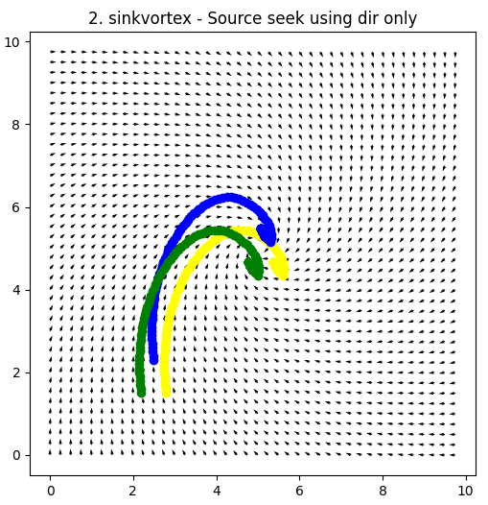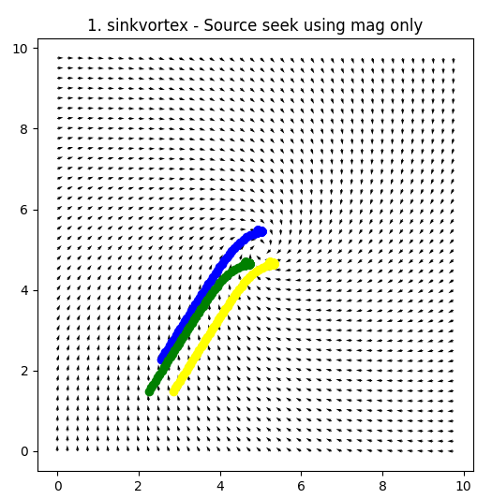

Figure 18: Find - Sink/Source in sinking Vortex using direction follow and mag.

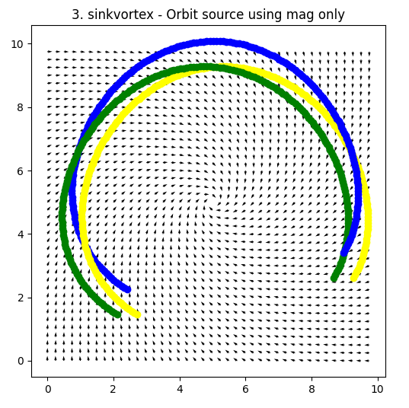
Figure 19: Orbiting Sinking Vortex using magnitude (plot normalized)
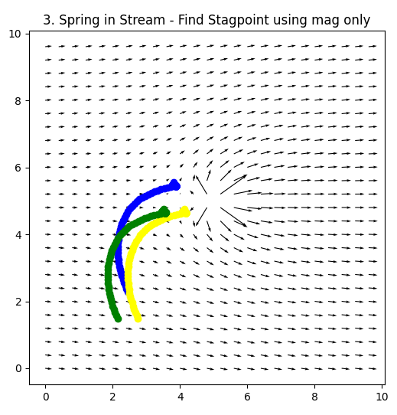

Figure 20: Find Stagnation Point in spring in stream.
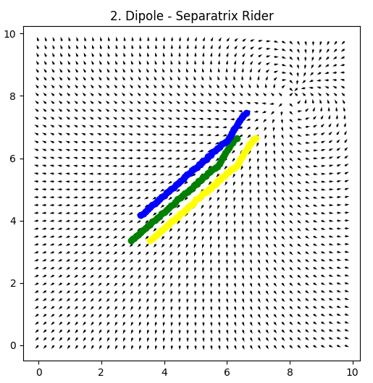
Figure 21: Ride Separatrix Line of a dipole
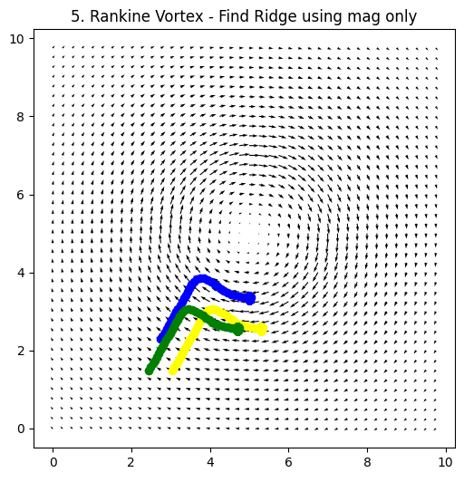
Figure 22: Fastest Flow of Ranking Vortex

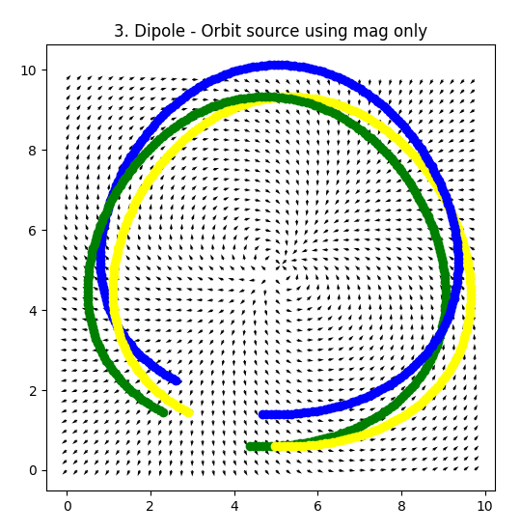
Figure 23: Equipotential line around a dipole

#7. Conclusions and Future Work

Immediate Next Steps
  - Create table of real life parallels for each region of interest.
  - Check separatrix rider on all separatrixes
  - Discuss the performance of the primitives (Qualitatively or Quantitatively)
  - Work on these features of interest: Boundary Layers (Fronts), voids, inflection points, fastest flow stream
  - Work on Paper for AIM

Possible Future Work:
- Plan and execute on physical test bed
- How does performance change with number of robots?
- Hyperparameter search of cluster formation variables for each primitive
- Extend work into 3 Dimensions
- Test with Noise can be added to the environments static (robust primitives)
- Test primitives on a stochastic environment (in simulation)
- Find a use case for a four robot cluster. Other than for redundancy or noise filtering.
- Look around for things in scalar fields that haven’t been done (inflection point?).

Impact and Applications

Future Test Bed ideas:
Some work was proposed to test in Kayaks at elkhorn Slough. Logistics complications, including not having an omnidirectional sensor and Covid-19 Restrictions. Other work has been done using RGB cameras, but was not able to get good resolution between the channels. I am proposing a mono channel approach for creating vector fields (fig 18). I also want to try modifying the old test bed, to see if I get better results.

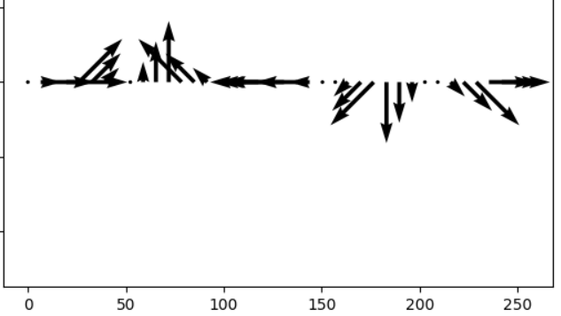
Figure 18. A wild mono-channel idea.

#7. References

[1] Gradient-Based Cluster Space Navigation for Autonomous Surface Vessels Thomas Adamek, Member, IEEE, Christopher A. Kitts, Senior Member, IEEE, and Ignacio Mas, Member, IEEE
[2] C. A. Kitts and I. Mas, "Cluster Space Specification and Control of Mobile Multirobot Systems," in IEEE/ASME Transactions on Mechatronics, vol. 14, no. 2, pp. 207-218, April 2009, doi: 10.1109/TMECH.2009.2013943.
[3] I. Mas, S. Li, J. Acain, and C. A. Kitts, “Entrapment/escorting and patrolling missions in multi-robot cluster space control,” in Proc. IEEE/RSJ Int. Conf. Intell. Robots Syst., St. Louis, MO, USA, Oct. 2009, pp. 5855– 5861.
[4] M. Woolsey, C. A. Kitts and M. A. Neumann, "Gradient-based Adaptive Navigation of Multiple Diving Autonomous Surface Vehicles," OCEANS 2022, Hampton Roads, Hampton Roads, VA, USA, 2022, pp. 1-8, doi: 10.1109/OCEANS47191.2022.9977006.
[5] C. A. Kitts and M. Egerstedt, “Design, control, and applications of real world multirobot systems [from the Guest Editors],” IEEE Robot. Autom. Mag., vol. 15, no. 1, p. 8, Mar. 2008.
[6] Lee, Robert K., et al. "3-d adaptive navigation: Multirobot formation control for seeking and tracking of a moving source." 2020 IEEE Aerospace Conference. IEEE, 2020.
[7] S. T. Hart and C. A. Kitts, "Unifying Control Architecture for Reactive Particle Swarms," in IEEE/ASME Transactions on Mechatronics, vol. 28, no. 2, pp. 873-883, April 2023, doi: 10.1109/TMECH.2022.3211155.
[8] Hart, Shae T., Jake Kamenetsky, and Christopher A. Kitts. "Dynamic Elliptical Shaping Control for Swarm Robots." IEEE Access 11 (2023): 17454-17470.
[9] McDonald, Robert T., et al. "Navigation of scalar fronts with multirobot clusters in simulation and experiment." IEEE Systems Journal 14.3 (2020): 3755-3766.
[10] C. A. Kitts, R. T. McDonald, and M. A. Neumann, “Adaptive navigation control primitives for multirobot clusters: Extrema finding, contour following, ridge/trench following, and saddle point station keeping,” IEEE Access, vol. 6, pp. 17 625–17 642, 2018.
[11] Trakas, Panagiotis S., Andreas Tantoulas, and Charalampos P. Bechlioulis. "Formation Control of Nonlinear Multi-Agent Systems with Nested Input Saturation." Applied Sciences 14.1 (2023): 213.
[12] Matveev, Alexey, et al. "Non-Gradient Based Tracking of Environmental Field Isolines in a Changing Medium by Dubins-Vehicle Type Robots." IEEE Transactions on Automatic Control (2023).
[13] Cooper, Ryan, et al. "Initial Study of Multirobot Adaptive Navigation for Exploring Environmental Vector Fields." 2019 IEEE Aerospace Conference. IEEE, 2019.
[14] C. A. Kitts, R. T. McDonald, and M. A. Neumann, “Adaptive navigation control primitives for multirobot clusters: Extrema finding, contour following, ridge/trench following, and saddle point station keeping,” IEEE Access, vol. 6, pp. 17 625–17 642, 2018.
[15] I. Mas, S. Li, J. Acain, and C. A. Kitts, “Entrapment/escorting and patrolling missions in multi-robot cluster space control,” in Proc. IEEE/RSJ Int. Conf. Intell. Robots Syst., St. Louis, MO, USA, Oct. 2009, pp. 5855– 5861.
[16] Wang, J., Guo, Y., Fahad, M., and Bingham, B., 2019, “Dynamic Plume Tracking by Cooperative Robots,” IEEE/ASME Transactions on Mechatronics, early access.
[17] Liddy, Tommie, et al. "Obstacle avoidance using complex vector fields." Proc. of the 2008 Australasian Conference on Robotics and Automation, Canberra, Australia. 2008. – Single Robot with artificial vector field.
[18] Nelson, Derek R., et al. "Vector field path following for miniature air vehicles." IEEE Transactions on Robotics 23.3 (2007): 519-529.
[19] Hu, Bin-Bin, et al. "Spontaneous-Ordering Platoon Control for Multirobot Path Navigation Using Guiding Vector Fields." IEEE Transactions on Robotics (2023).
[20] Braquet, Martin, and Efstathios Bakolas. "Vector field-based collision avoidance for moving obstacles with time-varying elliptical shape." IFAC-PapersOnLine 55.37 (2022): 587-592.
[21] Yao, Weijia, et al. "Singularity-free guiding vector field for robot navigation." IEEE Transactions on Robotics 37.4 (2021): 1206-1221.
[22] Rajabhandharaks, Danop, et al. "Indoor Testbed for Vector Field Multirobot Adaptive Navigation: Feasibility Study." International Design Engineering Technical Conferences and Computers and Information in Engineering Conference. Vol. 59292. American Society of Mechanical Engineers, 2019.
[23] Matveev, Alexey, et al. "Gradient-free tracking of unsteady environmental level sets in dynamic environments by a nonholonomic robot." IFAC-PapersOnLine 53.2 (2020): 9256-9261.
[24] Finite-Time Estimation and Control for Multi-Aircraft Systems Under Wind and Dynamic Obstacles – Only has attract and repulse sink/source vectors. No vortexes.
[24] R. K. Lee, C. A. Kitts, M. A. Neumann and R. T. Mcdonald, "Multiple UAV Adaptive Navigation for Three-Dimensional Scalar Fields," in IEEE Access, vol. 9, pp. 122626-122654, 2021, doi: 10.1109/ACCESS.2021.3107854.
[25] Thangavelautham, Jekan, and Yinan Xu. "Co-Evolution of Multi-Robot Controllers and Task Cues for Off-World Open Pit Mining." arXiv preprint arXiv:2009.09149 (2020).
[26] Kalita, Himangshu, et al. "Guidance, navigation and control of multirobot systems in cooperative cliff climbing." arXiv preprint arXiv:1701.07553 (2017).

